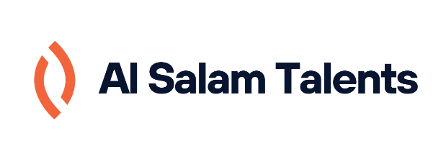
Program: ICT – Programming
Project Title: Al Salam Talents Platform
Student Name: Maryam Yusuf Haji - 202100516
Student Contact: 1maryamyousiff@gmail.com
Polytechnic Supervisor: Mr. Husain Alzain

The purpose of this project is to develop a centralized, secure, web-based platform that connects Bahrain Polytechnic students with Al Salam Bank, acting as a student-led, in-house digital marketing agency. The goal is to allow students to gain real-world experience by working on actual campaigns for the bank, while Al Salam Bank benefits from cost-effective, innovative marketing solutions directly managed through the platform. This collaboration aims to replace traditional outsourcing to external agencies, promoting sustainability and professional development from within.
The main concept of the platform revolves around creating a communication and task management ecosystem for students (freelancers), Al Salam Bank representatives (clients), and administrative staff (platform supervisors). The platform offers a complete workflow—starting from project posting by the bank, student application, task assignment, progress tracking, communication, feedback, and approval.
The user registration process includes role-based access control for students, clients, and admins. Each user has a dedicated dashboard, tailored to their role’s functionality. Students can create and manage detailed profiles including bios, portfolios, and skillsets, which can be browsed by the client to find suitable candidates. The messaging system supports file sharing and structured chat threads to ensure clear collaboration. Notifications are integrated to alert users of new tasks, project status changes, and deadlines.
From the client’s side, the platform enables posting detailed project briefs and viewing freelancer profiles and applications. Project managers can track the progress of deliverables in real-time, request revisions, and approve final submissions through a structured approval workflow. Administrators, on the other hand, have access to analytics, and system usage metrics to maintain platform integrity and performance.
The system also includes additional features such as saving and un-saving projects, reviewing freelancer performance, assigning freelancers based on availability, and maintaining communication through in-app chat and optional video calls. Plans for future development include expanding to mobile platforms, and payment gateway integration.
Overall, the Al Salam Talents platform adheres to the bank's data privacy and branding standards while serving both educational and professional purposes. It helps students enhance their employability by building real-world portfolios and allows Al Salam Bank to engage in innovative, student-led marketing initiatives in a cost-efficient, secure environment.

